Day28

DIY

Q1.How to enable Amazon SES to receive inbound emails ?

Solution –

 Go to S3  click on create bucket

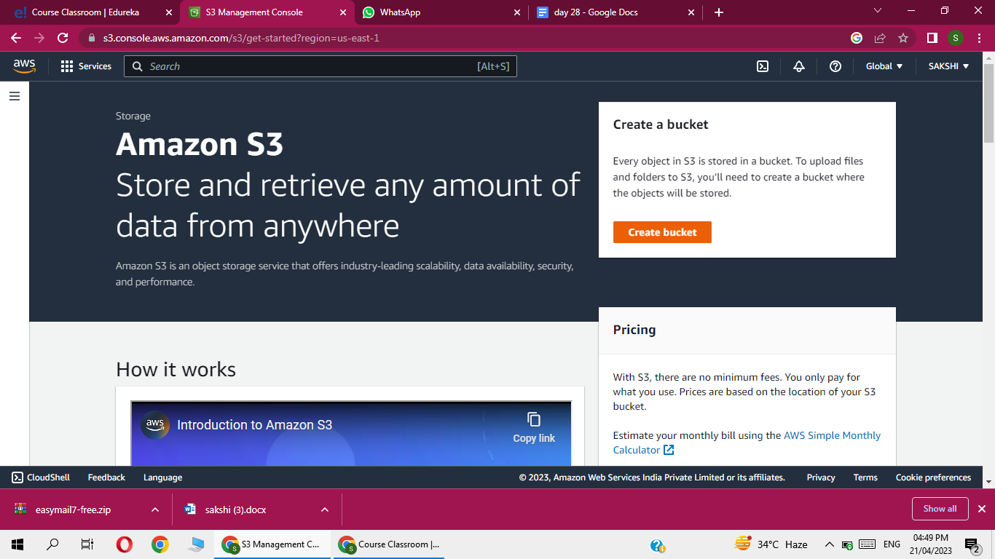

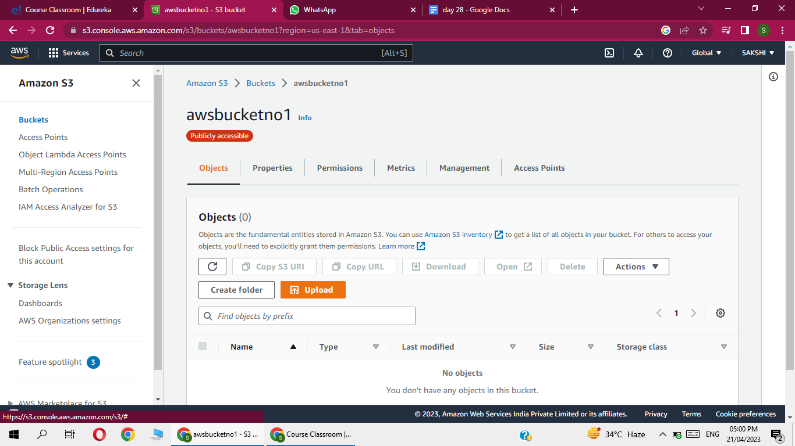

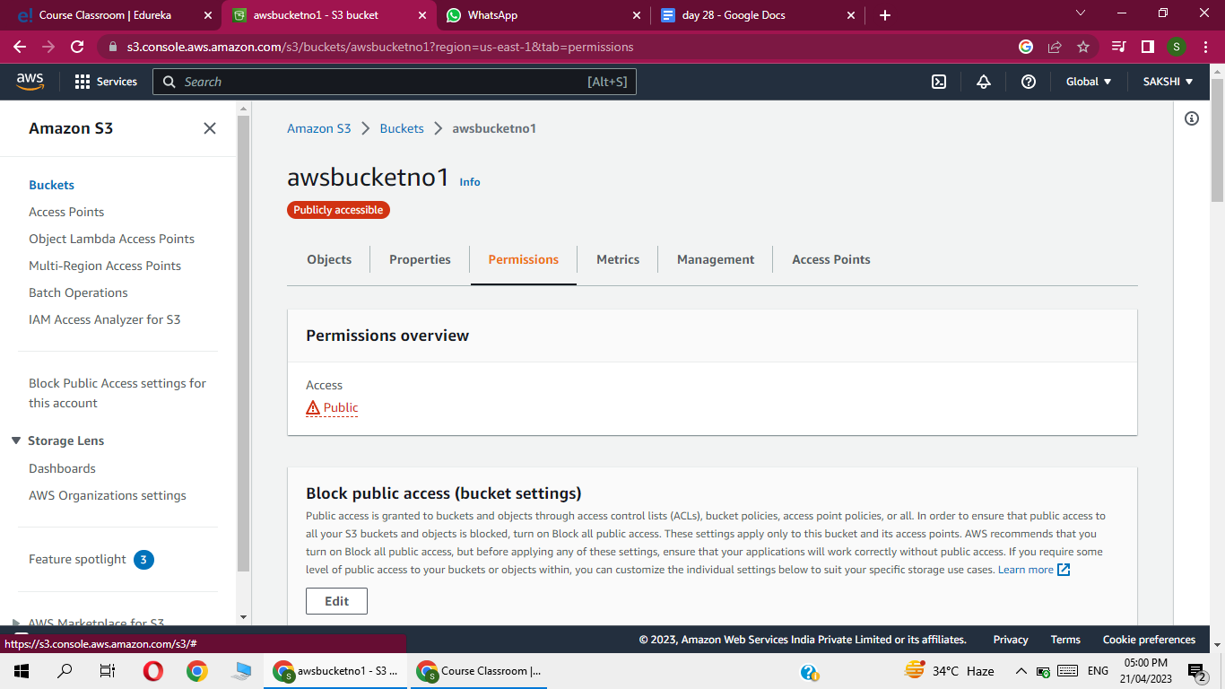

We have  to only  change resource ,give bucketarn there

And aws source account  here give account id  from which account i have to give permission to ses  to write in bucket

<https://docs.aws.amazon.com/ses/latest/dg/receiving-email-permissions.html>

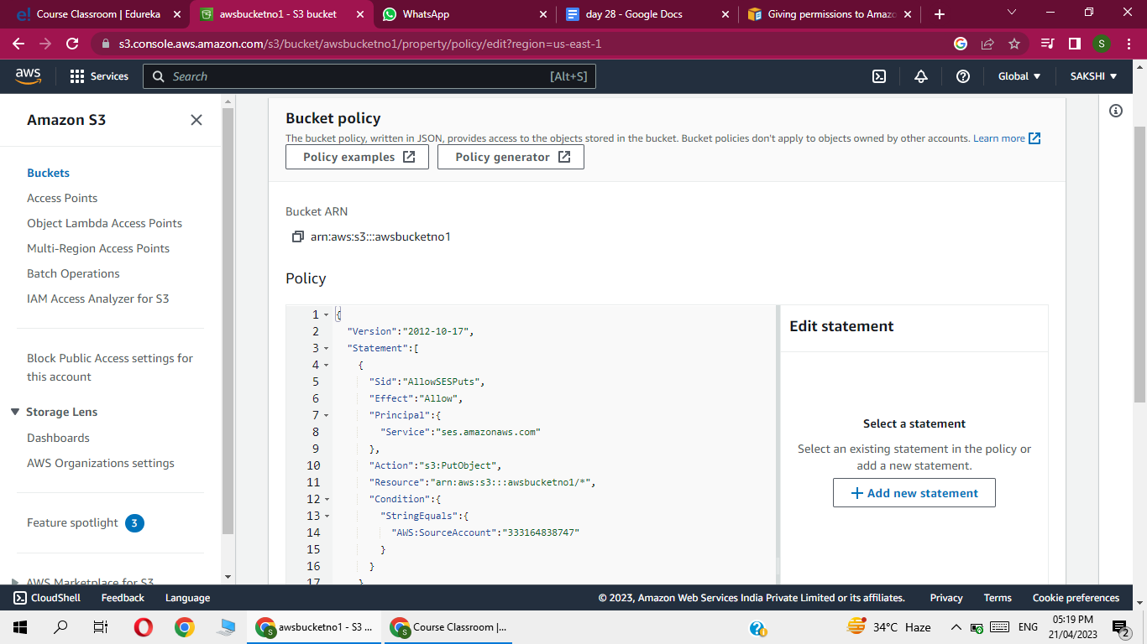

Click on save changes

 Now go to SES

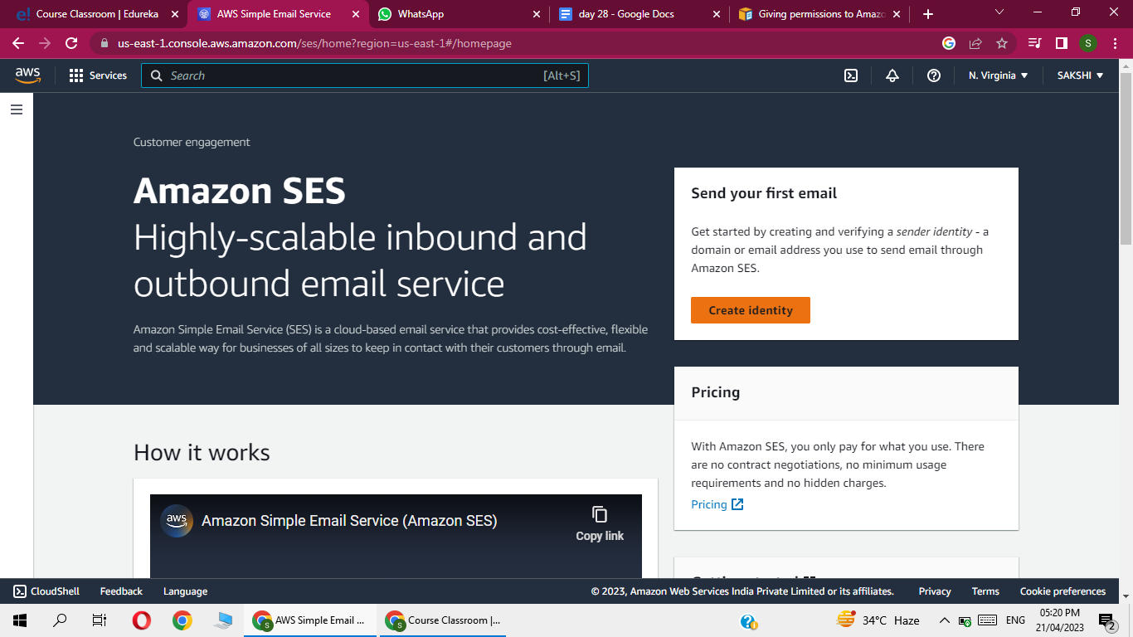

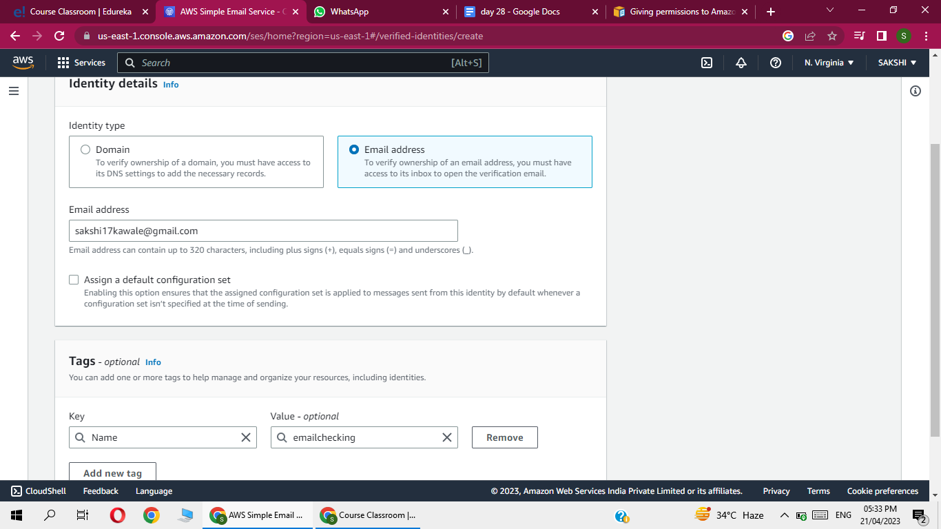

Click on create identity

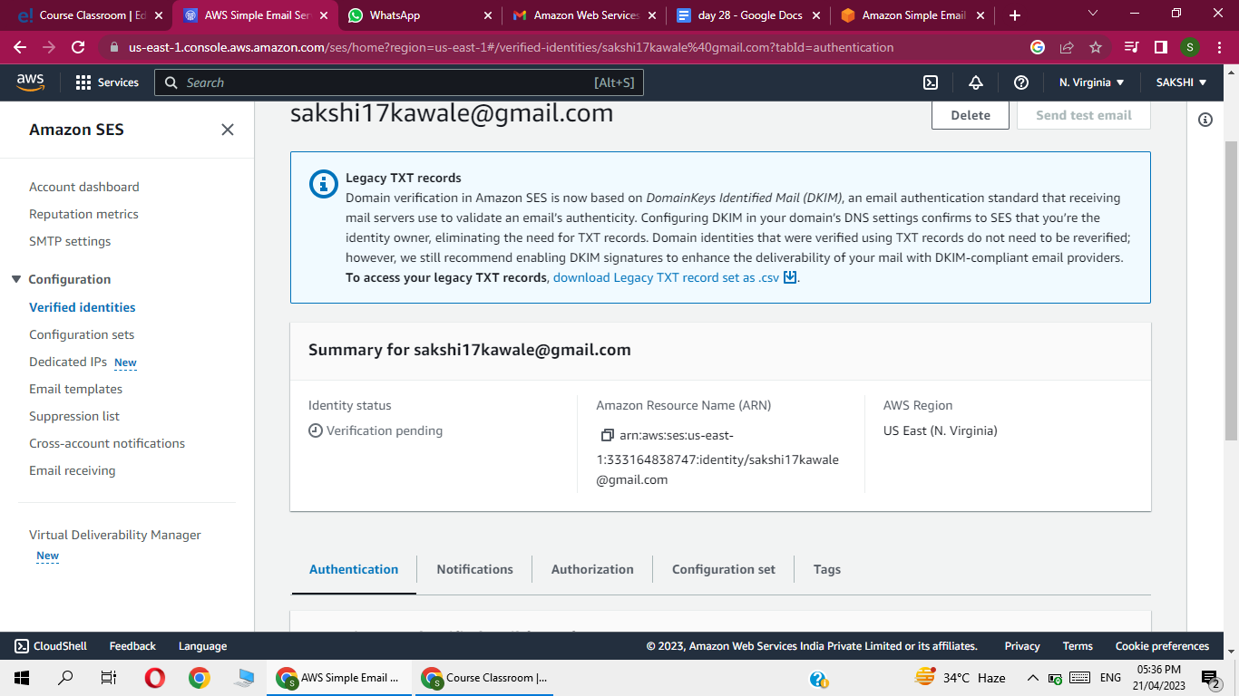

We can se status is pending then go to identity and check the  email

Check the email

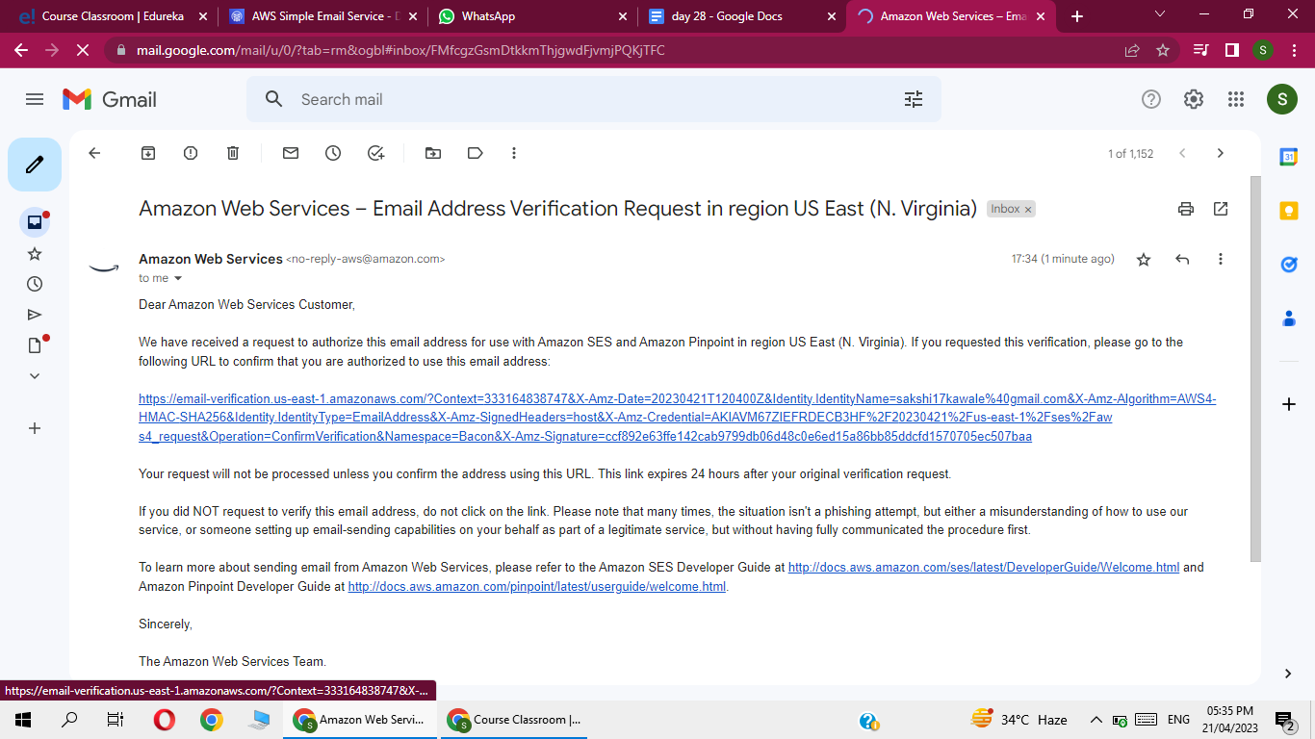

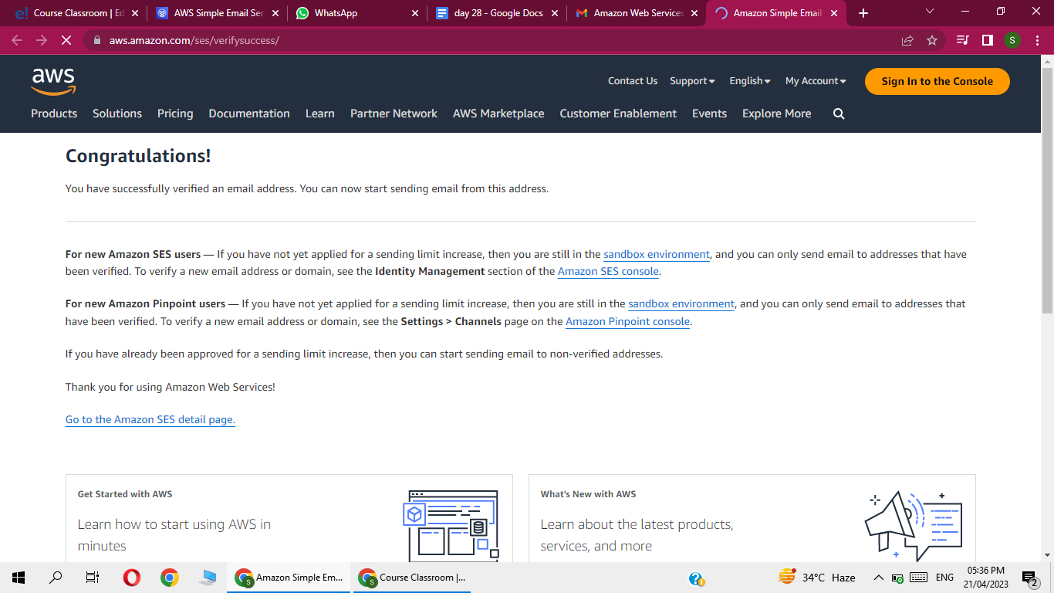

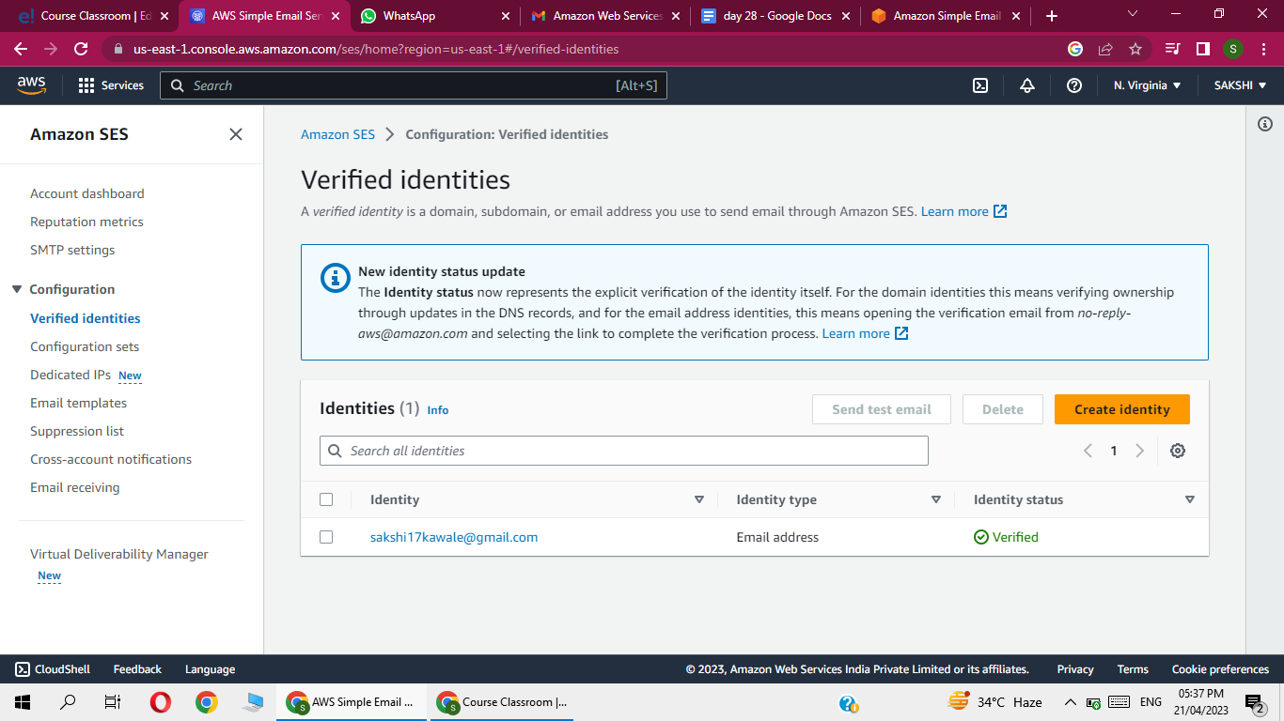

 Now go to email receiving option

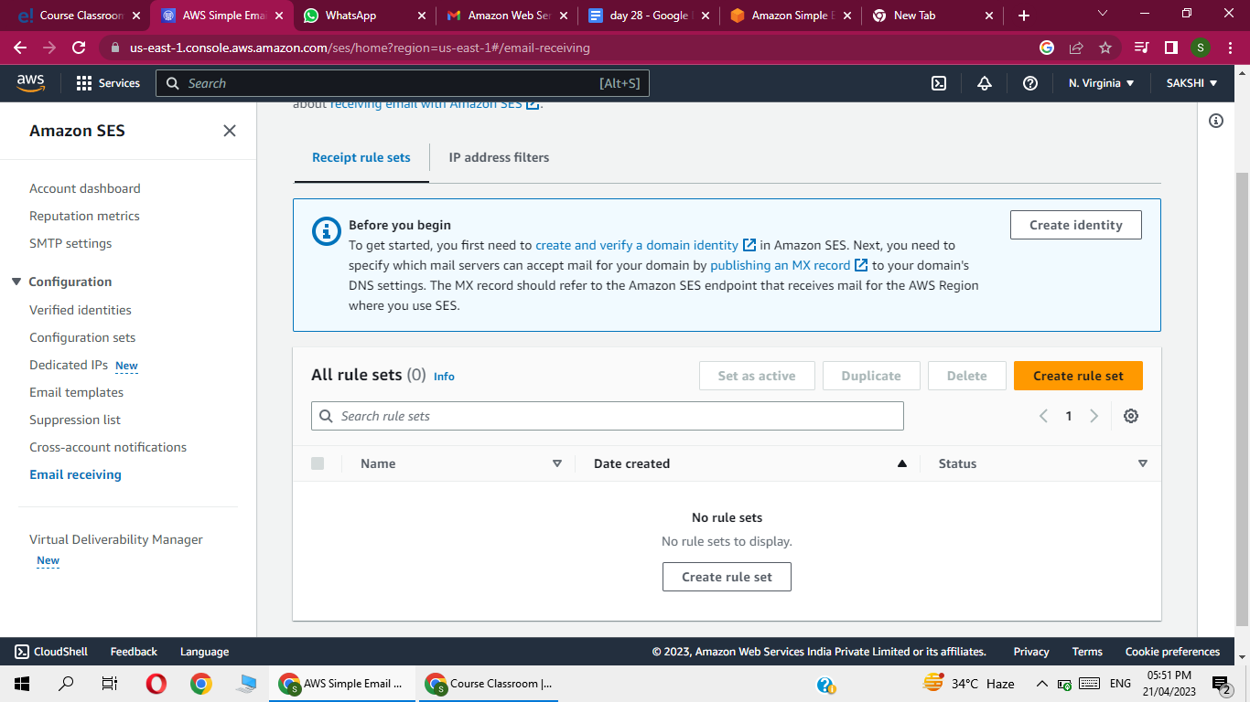

Click on create rule set

Means what message CAN GET TO

Receivers after receiving the email

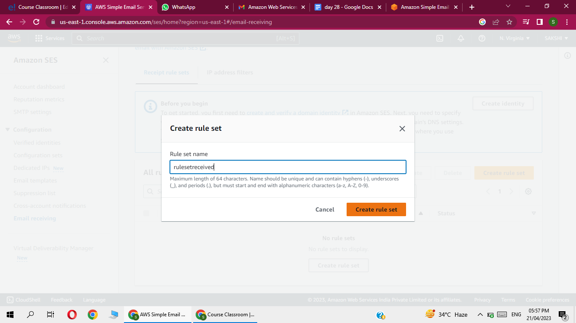

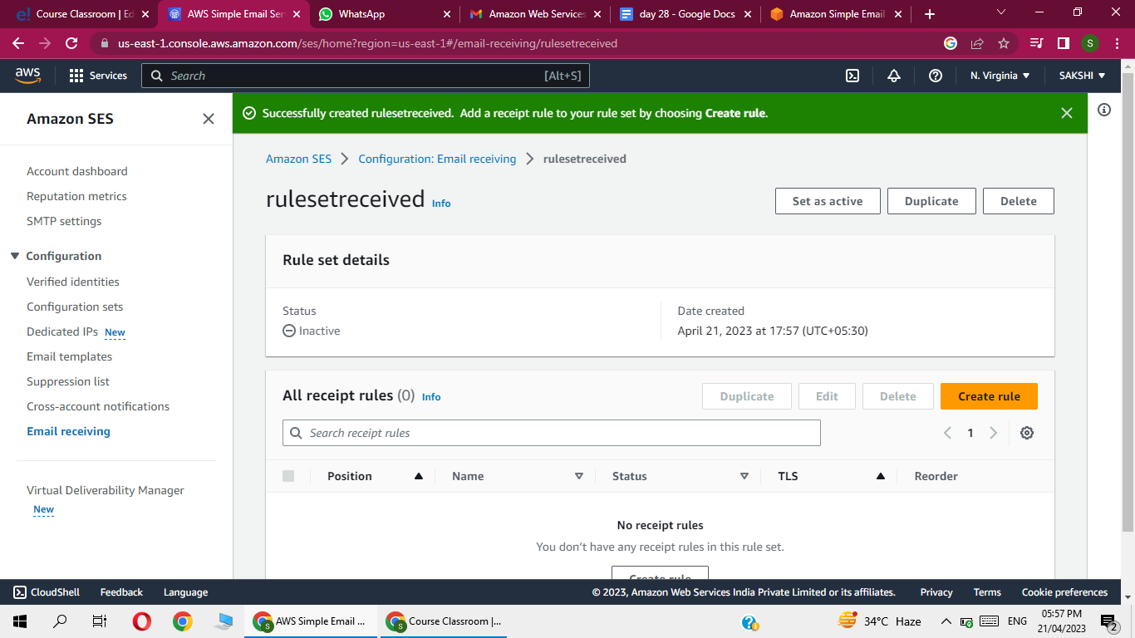

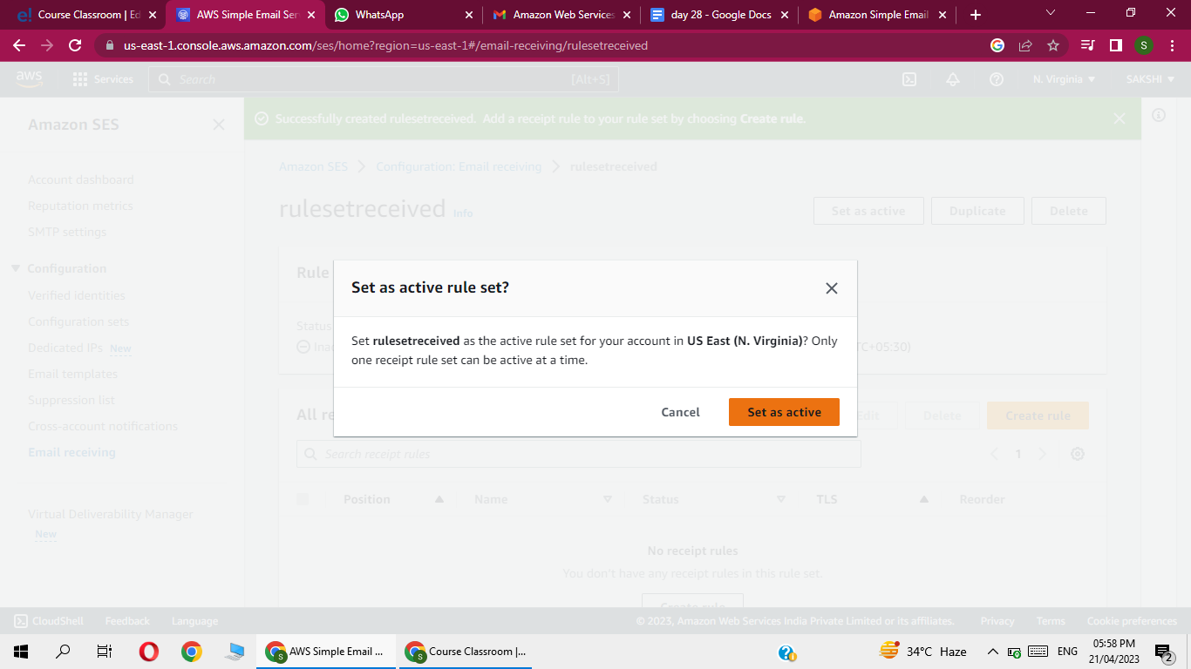

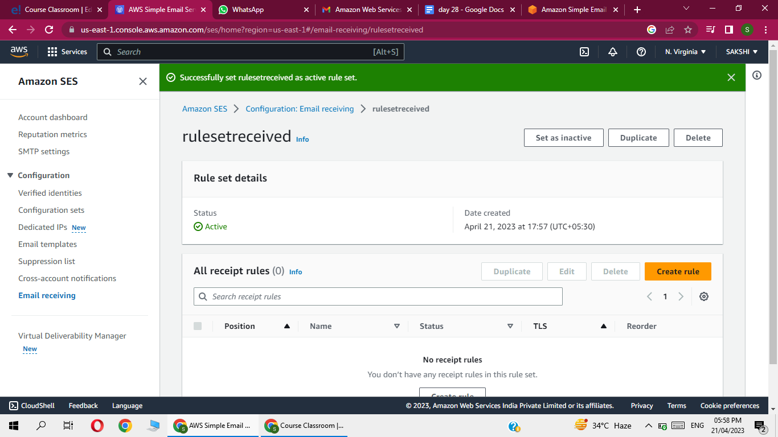

Now create after active rule set create rule inside it

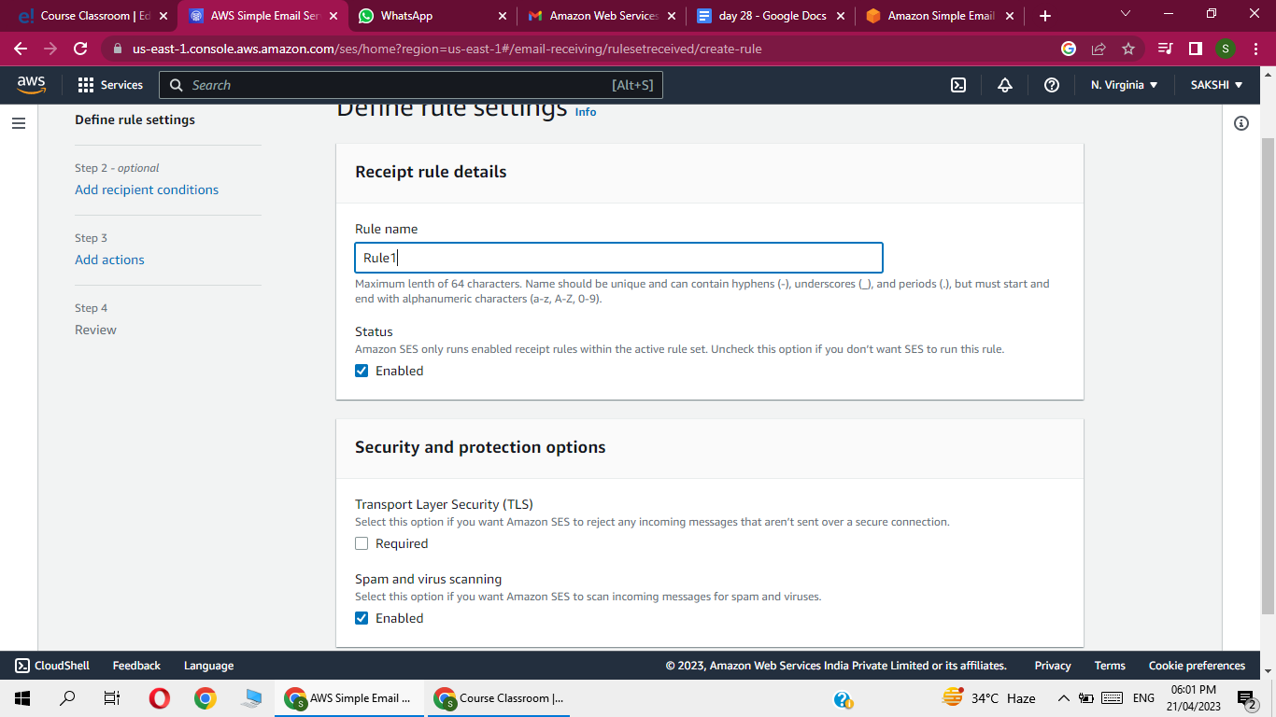

By default it is enable but  if it not we  should enable it  bcz we have to  apply the rule inside  objects coming into  bucket Or inside ses

So enable it

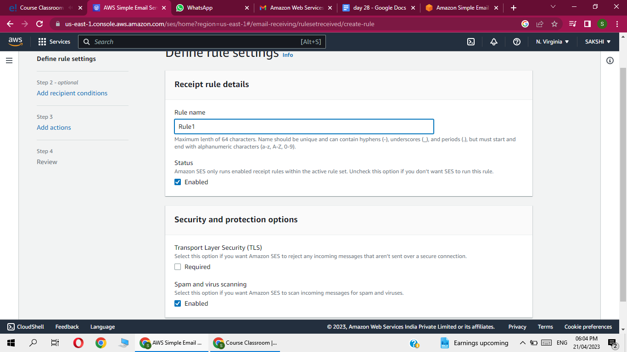

Now go to

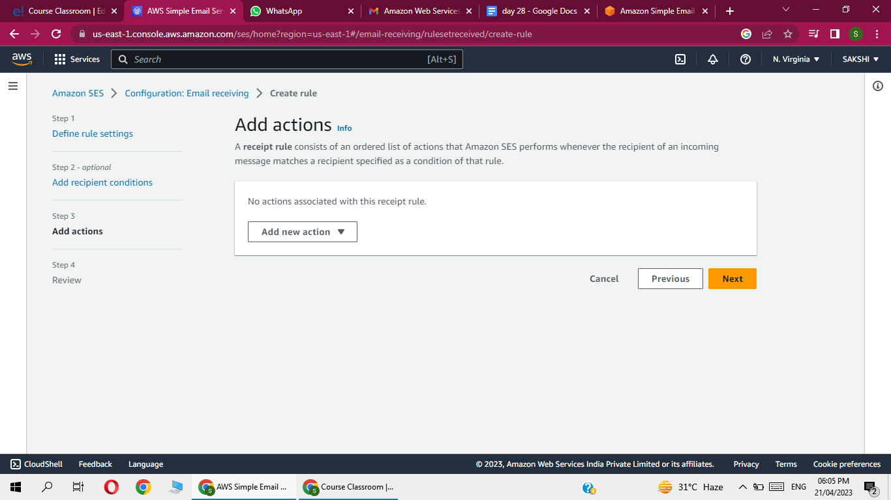

I.e.  in case any email coming from outside to SES

 Send to s3 bucket

 Click Deliver to s3 bucket

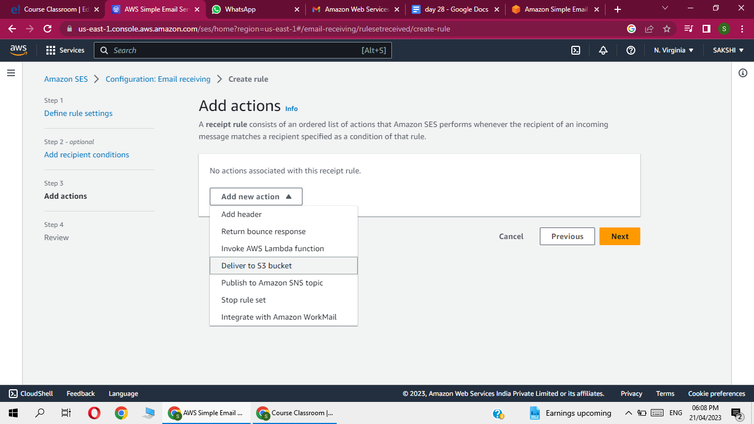

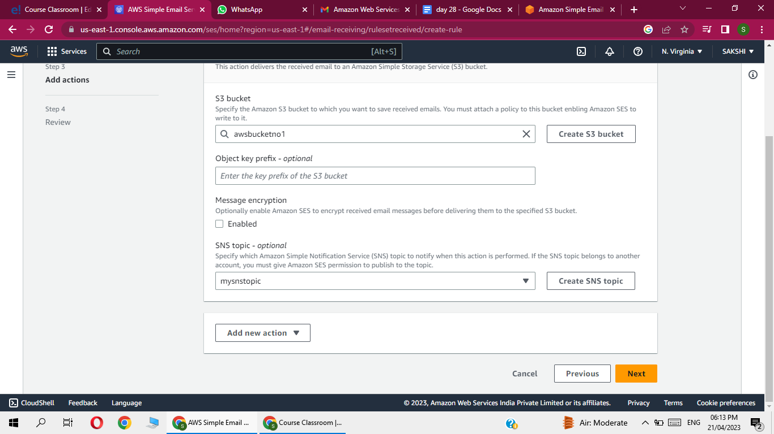

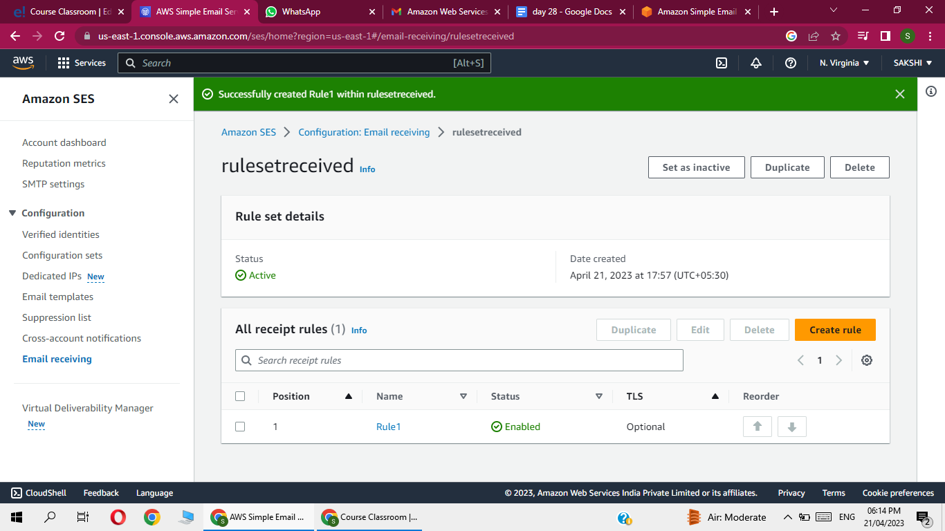

Again go verified identities ,

Now form this email id i want to send the email to SES

 So ,  Click on  send test  email

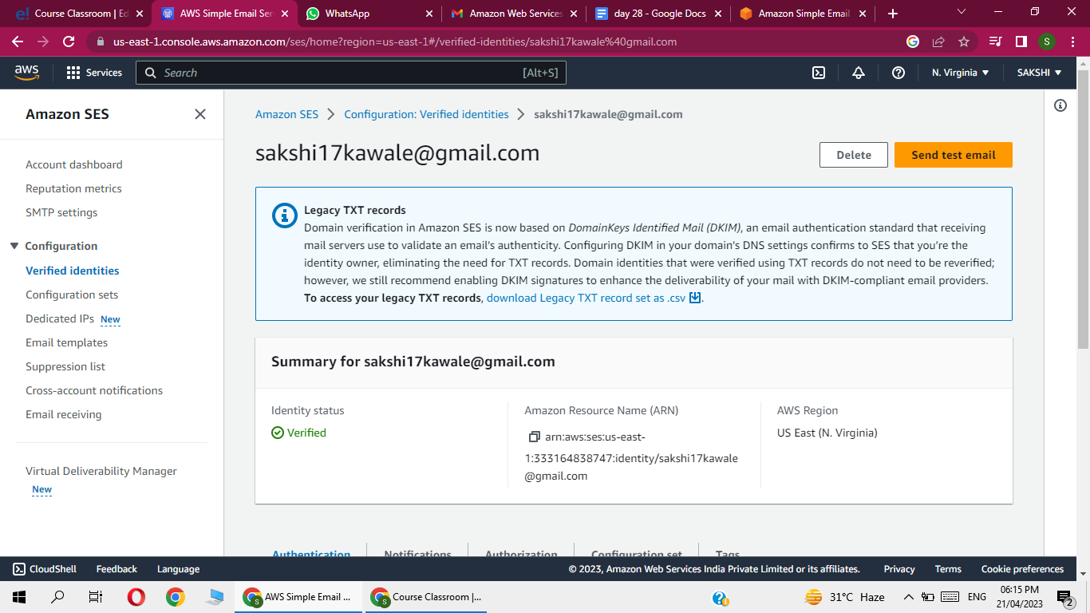

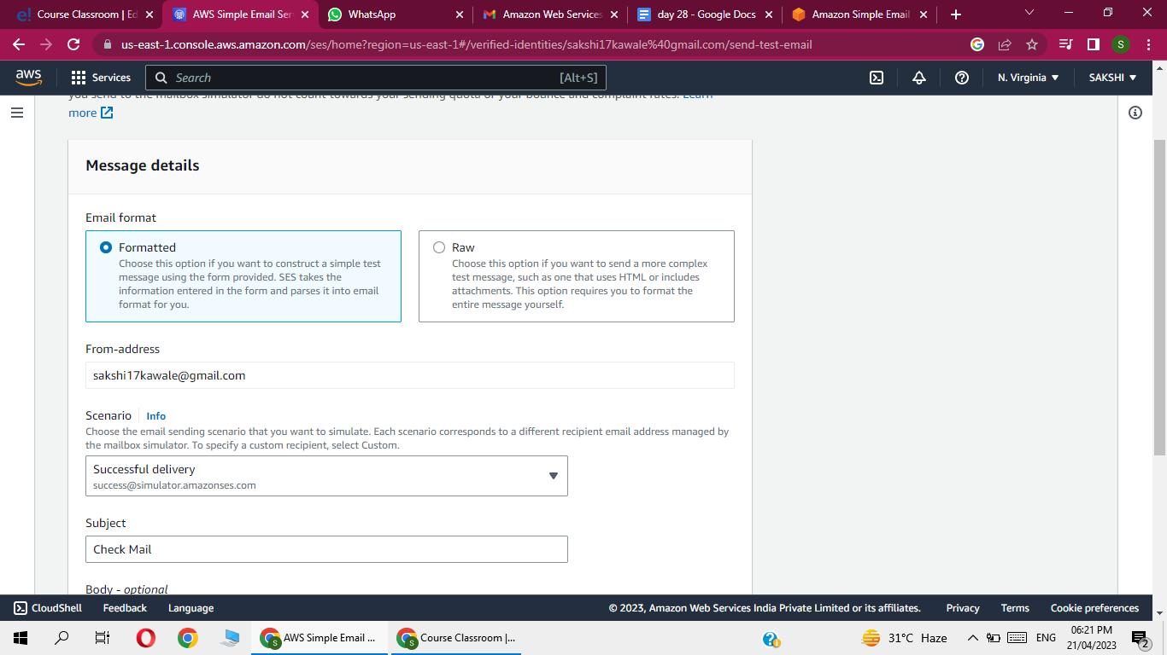

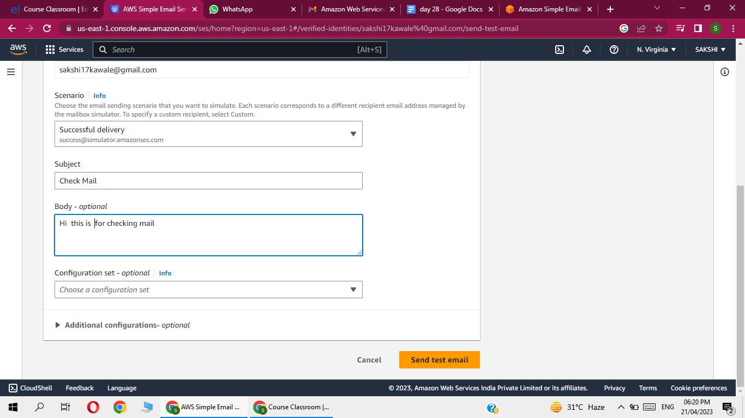

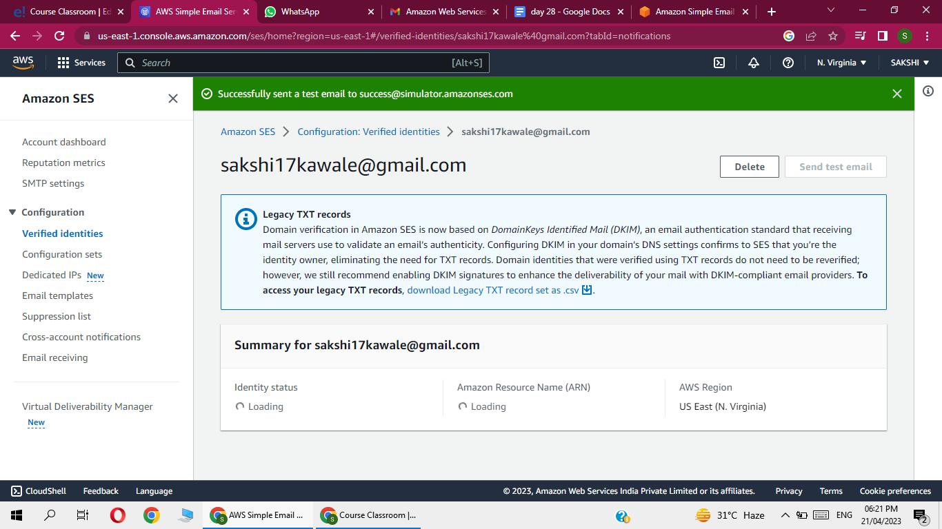

Now go to s3  and check the mail receive or not

It take time

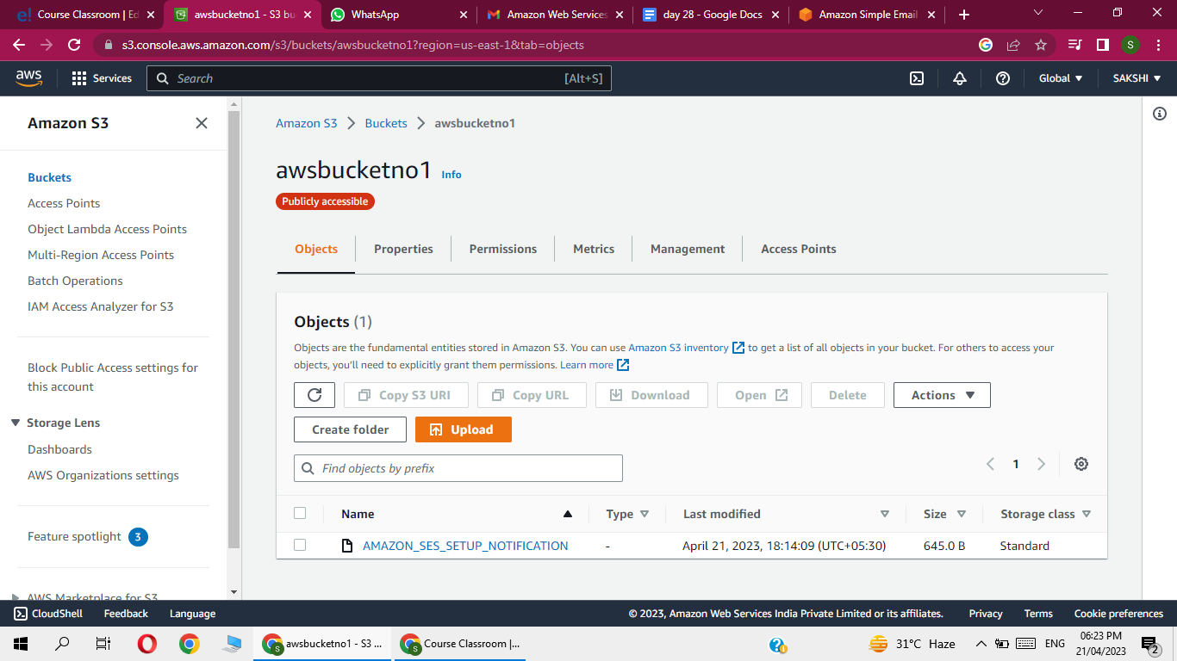

Click on open

